ADANI NATURAL RESOURCES
Talabira II & III Open Cast Project
Performance Monitoring & Improvement Opportunities
in OB & Coal Operations through FMS & FUMS Data
Current System Limitations · Dynamic TF & 3D TLS · CAN Bus Monitoring
Availability-Utilization Reliability Analysis · Digital Mining Technology

Prepared by: Sushant Rathore | Intern, Adani Natural Resources
Submitted to: Nabal Kishor Sharma, Talabira II & III CH
Report Date: July 2026
Data Source: Fleet Management System (FMS) & Fuel Management System (FUMS), Adani Natural Resources

Table of Contents
- Introduction & Mine Overview
- Current FMS Structure and Limitations
- Availability, Utilization & Reliability Analysis
- Dynamic Trip Factor (TF) and 3D TLS Reconciliation
- CAN Bus Integration for Measurements
- Towards Digital Mining System
- Conclusion

1. Introduction & Mine Overview
This report presents a comprehensive assessment of the Fleet Management System (FMS) and Fuel Management System (FUMS) at Talabira II & III Open Cast Project (OCP). The study evaluates key operational performance indicators, including equipment availability, utilization, productivity, fuel consumption, overburden (OB) removal, and Run-of-Mine (ROM) coal transportation.
The primary objective is to identify data-driven opportunities for improving operational efficiency and production visibility by leveraging existing FMS, FUMS, and survey data.

1.1 Project Background
Parameter | Details
Project Name | Talabira II & III Open Cast Project (OCP)
Location | IB Valley Coalfield, Sambalpur & Jharsuguda Districts, Odisha
Owner | NLC India Ltd (Neyveli Lignite Corporation India Ltd)
Mine Developer & Operator (MDO) | Adani Natural Resources
Execution Contractor | DIMPL
Leasehold Area | 1,914 Hectares
Total Coal Reserves | 554 Million Tonnes (MT)
Normative Capacity | 20 MTPA (expandable to 23 MTPA Peak Capacity)
Mine Life | 34 Years
Coal Grade | G12 (3700Kcal/kg – 4000Kcal/kg)
Production Commencement | April 2020
End Use Plant | Talabira TPS- 4*800MW (15MTPA)  Tuticorin TPS- 2*500MW (5MTPA)

1.2 Coal Geology & Mining Method
Talabira II & III Open Cast Project is situated within the Gondwana-age IB Valley Coalfield of Odisha. The deposit comprises multiple stacked coal seams of bituminous to sub-bituminous rank. The primary economic seams are RT-II and RT-I, each exceeding 30 metres in thickness. The IB-Top and IB-Bottom seams produce high-grade G10–G15 thermal coal, which is blended to achieve a consistent calorific value suitable for power generation. The shallow Lajkura seam has a favourable stripping ratio of 1.09.

A significant operational constraint is the mine’s proximity to the Hirakud Reservoir and Bheden River. This limits conventional drill-and-blast operations near the perimeter due to strict blast vibration controls aimed at preventing structural damage and water ingress. As a result, the Surface Miner fleet plays a critical role in boundary areas by enabling blast-free extraction.

Three extraction methods are used in combination:

- Shovel-Dumper: Primary method for bulk overburden (OB) removal and Run-of-Mine (ROM) coal haulage across active benches.

- Drill & Blast: Selectively applied for hard sandstone layers in the upper overburden where mechanical cutting is uneconomical.

- Continuous Surface Mining: Utilising L&T KSM 403 and Wirtgen surface miners for blast-free coal extraction, with direct loading into tippers through FEL’s.

Note- The selection of the mining method depends on geological conditions, rock strength, environmental constraints, and production requirements.

1.3 HEMM Fleet at Talabira — Comprehensive Inventory

The mine operates a fleet of 199 Heavy Earth Moving Machinery (HEMM) units, all equipped with GPS-based telematics and integrated into the Fleet Management System (FMS). The fleet is organised into six functional equipment groups, as summarised

Equipment Group | Make & Model | Units | Key Specification | Role
Tipper | BharatBenz 3528CM / 3128CM | 54 | High-capacity road-legal hauler | ROM coal haulage to stock
Tipper | Volvo FMX 440 | 12 | Premium heavy-duty hauler | ROM coal haulage to stock
Dumper | Komatsu HD785 (100T) | 10 | 100T payload, TF = 42 m³ | OB removal — heavy haul
Dumper | Sany SRT55 / SRT65 (60–70T) | 67 | 60–70T payload, rigid body | OB removal — standard haul
Excavator | Komatsu PC2000 (200T) | 1 | 12.3 m³ bucket, heavy production | OB & coal face excavation
Excavator | Sany SY365–SY750 (38T–135T) | 11 | 2.0–8.0 m³ bucket | OB & coal face excavation
Excavator | Kobelco SK250–SK850 (25T–80T) | 16 | 1.0–5.4 m³ bucket | Seam cleaning, utility tasks
Front End Loader | Volvo L150H | 14 | High-capacity wheel loader | face cleanup
Front End Loader | SDLG LG958L | 2 | 3.0 m³ bucket, 5T load | Short-haul support loops
Surface Miner | L&T KSM 403 | 4 | 4,000mm drum, 350mm depth, 950HP | Blast-free continuous coal cutting
Surface Miner | Wirtgen 2200SM 3.8 | 1 | 3,800mm width, up to 35 MPa rock | Medium-hard formation cutting
Surface Miner | Wirtgen 220SM | 1 | 2,200mm width, up to 50 MPa rock | High-strength seam cutting
Diesel Bowser | Various (mobile tankers) | 6 | RFID-equipped fuel dispensing | On-site refuelling (FUMS)
TOTAL FLEET |  | 199 | All GPS-tracked via FMS | OB + ROM + Support

2. Current FMS Structure and Limitations

2.1 Introduction to Fleet Management System

A Fleet Management System (FMS) is a GPS and telematics-based platform that enables real-time monitoring and management of Heavy Earth Moving Machinery (HEMM) operating across a mine. By integrating onboard tracking devices with a central server and web-based dashboard, the system provides continuous visibility into equipment location, operational status, production activities, and fuel consumption, allowing the entire fleet to be monitored from a single interface.

At Talabira II & III Open Cast Project (OCP), the FMS is deployed across the entire GPS-enabled HEMM fleet and serves as the primary platform for tracking equipment movement, utilisation, production, and overall operational performance.

Objectives of FMS

Objective | What It Enables
Fleet Visibility | Real-time tracking of HEMM location and operational status across the mine.
Production Monitoring | Monitoring of overburden (OB) haulage and ROM coal transportation through automated trip and production records.
Fuel Monitoring | Recording and analysis of machine-wise diesel consumption using the Fuel Management System (FUMS).
Equipment Utilization | Evaluation of availability, utilization, idle hours, and breakdown hours for each machine.
Decision Support | Providing reliable operational data for production planning, maintenance scheduling, and management review.

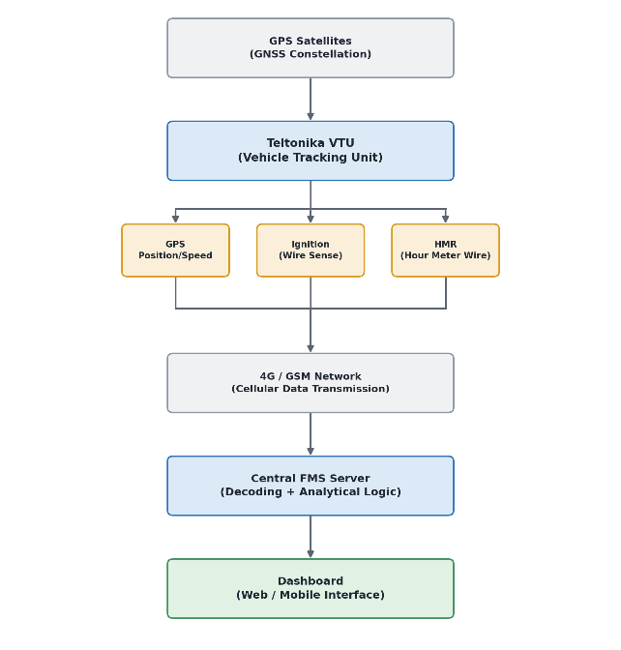
2.2 Overall Talabira FMS Architecture
The FMS at Talabira operates as a five-layer system: satellite signals received by onboard tracking hardware, transmitted via cellular network to a central server, processed into KPIs, and presented through a web dashboard.

The complete architecture is shown as follows:

Observation: The onboard VTU only acquires and transmits raw machine data (GPS, ignition status, and HMR).

All higher-level KPIs such as availability, utilization, idle hours, production, and fuel efficiency are generated through server-side analytical processing.

Directly Measured Parameters
Parameter | Source Hardware | Measurement Type | Notes
GPS Position (Lat/Long) | GNSS satellite + VTU | Direct — satellite triangulation | Accuracy ±2.5m open sky; degrades near pit walls
Speed | GPS position delta | Derived from GPS — not mechanical | Computed from position change per second; zero at standstill
Ignition Status (ON/OFF) | Ignition wire → VTU digital input | Direct — binary 0/1 signal | Detected within seconds of key turn; basis of all availability calculations
HMR (Engine Hours) | Hour meter pulse wire → VTU | Direct — mechanical counter pulse | Can drift after ECU replacement or workshop intervention
Fuel Dispensed (Litres) | RFID tag on machine + flowmeter at bowser | Direct — volumetric flow measurement | FUMS system; 100% RFID coverage at Talabira
ROM Coal Tonnage | Weighbridge at ROM stockyard | Direct — weight measurement | Gross weight − tare weight = net ROM coal; independent of FMS

Derived / Computed Parameters (Server-Side)
KPI | Computation Logic | Input Signals Used
Availability Hours | Shift Hours − Breakdown Hours | Ignition status + HMR
Idle Hours | Engine ON + Speed=0 + Not in trip cycle | Ignition + GPS speed + geofence
OB Trips | Geofence entry (load zone → dump zone) count | GPS position vs stored geofences
OB CUM (m³) | OB Trips × Trip Factor (TF) | GPS trips + static TF constant
Availability % | Availability Hours ÷ Shift Hours | Availability Hours + Shift Hours
Utilization % | Productive Hours ÷ Availability Hours | Trip cycle time + availability hours
Diesel L/Hr | Fuel Dispensed ÷ Operation Hours | FUMS litres + HMR hours

OBSERVATION: The current system directly measures GPS location, speed, ignition status, HMR, fuel dispensing, and ROM coal tonnage. Higher-level KPIs are generated through server-side analytical logic rather than direct sensing.

2.3 Existing Capabilities
Based on the data acquisition and processing logic described above, the current Talabira FMS provides the following capabilities:
- GPS-based tracking of equipment location and movement
- Trip detection and counting for OB haulage
- Fuel dispensing monitoring and reporting (RFID-based)
- Availability calculation (Shift Hours vs. Breakdown Hours)
- Utilization calculation (Operating Hours vs. Available Hours)
- HMR acquisition and hour-based reporting
- Standard MIS reports covering production, fuel, and utilization
- Web and mobile dashboard for live and historical visualization

2.4 Current Limitations
While the existing FMS provides reliable fleet monitoring and operational reporting, the current implementation has several inherent limitations that affect production visibility and operational decision-making. The key limitations identified are:
- Static Trip Factor (TF)–based estimation of overburden (OB) production.
- Limited productivity assessment for stationary equipment such as excavators.
- Absence of CAN Bus integration for advanced machine health and operational monitoring.
- No direct payload measurement for OB haul trucks.
- Limited real-time decision support and dispatch optimization.

NOTE: These limitations are examined in detail in the subsequent chapters, along with their operational impact and potential improvement opportunities.

3. Fleet Availability, Utilization & Reliability Analysis
3.1 Introduction
Four KPIs together define fleet health at Talabira. No single metric tells the full story.
KPI | Definition | What It Reveals | Management Implication
Availability % | Avail. Hours ÷ Shift Hours | Proportion of scheduled time machine was mechanically fit | Maintenance effectiveness — how well the fleet is kept ready for work
Utilization % | Productive Hours ÷ Avail. Hours | Proportion of available time converted into productive output | Operational efficiency — how well available machines are deployed by operations
MTBF | Avail. Hours ÷ No. of Failures | Mean time between breakdown events for a machine | Reliability — longer MTBF = equipment fails less often
MTTR | Breakdown Hours ÷ No. of Failures | Mean time taken to restore a machine after failure | Repair capability — lower MTTR = workshop responds and resolves faster

Availability = MTBF ÷ (MTBF + MTTR)

This equation means availability can only improve in two ways: machines break down less often (higher MTBF) or are repaired faster when they do (lower MTTR). Understanding which lever dominates at Talabira determines where maintenance investment will have the most impact. This chapter provides that diagnosis.

3.2 Fleet Availability Analysis
Metric | March | April | May
Fleet Availability % | 69.2% | 61.6% | 61.4%
Total Shift Hours (fleet) | 1,50,166 | 1,45,335 | 1,50,249
Total Availability Hours | 1,00,265 | 85,588 | 85,916
Total Breakdown Hours | 49,901 | 59,746 | 64,333
Breakdown as % of Shift | 33.2% | 41.1% | 42.8%
Non-Operational Units | 7 | 9 | 14

Fleet availability declined from 69.2% in March to 61.6% in April, a reduction of 7.6 percentage points, and remained almost unchanged at 61.4% in May.
The absence of any meaningful recovery during the study period indicates that the loss in fleet availability was sustained rather than temporary, resulting in a consistently lower level of fleet readiness by the end of May.
Between March and April, the fleet lost 14,677 availability hours, equivalent to approximately 20 machines being unavailable for an entire month.
Although the overall fleet size remained unchanged, this lost capacity was not recovered in May. The number of non-operational machines increased steadily from 7 in March to 14 in May, indicating a progressive reduction in available fleet capacity during the study period.

3.2.2 Equipment Group Availability
Equipment Group | March | April | May | 3M Change | Status
Surface Miner | 90.4% | 52.8% | 57.0% | −37.4 pts | ▼ Critical
Tipper | 73.8% | 62.5% | 62.1% | −11.7 pts | ▼ Declining
Dumper | 64.8% | 60.9% | 56.2% | −8.6 pts | ▼ Declining
Excavator | 65.7% | 57.1% | 60.5% | −5.2 pts | ▼ Declining
Front End Loader | 80.8% | 70.0% | 82.0% | +1.2 pts | → Stable

The decline in availability was not uniform across equipment groups. While most production-critical fleets recorded a sustained reduction in availability, the magnitude and recovery pattern varied considerably between equipment categories.
The Surface Miner fleet exhibited the sharpest decline, with availability falling from 90.4% in March to 52.8% in April before recovering only marginally to 57.0% in May.
Given the small fleet size (six machines), extended downtime of even a limited number of units can significantly influence the group average.
Nevertheless, the continued suppression of availability into May suggests that the issue persisted beyond a single isolated breakdown event.
The Dumper fleet presents the greatest operational concern, availability declined consistently from 64.8% in March to 56.2% in May, with no evidence of recovery.
As the primary fleet responsible for overburden haulage, this sustained decline directly reduces effective hauling capacity and places additional pressure on the remaining operational dumpers.
Front End Loaders were the only major equipment group to recover during the study period, with availability improving from 70.0% in April to 82.0% in May.

3.3 Fleet Utilization Analysis

3.3.1 Fleet-Level Trend and the Productive Hours Contraction
Fleet utilization declined from 75.3% in March to 65.3% in April before partially recovering to 67.9% in May. Reading utilization percentages in isolation understates the severity.
Because availability also contracted, estimated total productive hours shrank from approximately 75,500 in March to 55,900 in April — a contraction of 19,600 hours, equivalent to the entire productive output of 26 machines disappearing from the operation in a single month.

Metric | March | April | May
Fleet Utilization % | 75.3% | 65.3% | 67.9%
Fleet Availability % | 69.2% | 61.6% | 61.4%
Utilization Gap % (1 − Util%) | 24.7% | 34.7% | 32.1%
Effective Productive Machine Hours | ~75,500 | ~55,900 | ~58,300

3.4 Breakdown Analysis

3.4.1 Breakdown Trend — Scale and Direction

Fleet breakdown hours increased consistently from 49,901 hours in March to 64,333 hours in May, representing a net increase of 14,432 hours over the study period.

No improvement or stabilization was observed across the three months. By May, total breakdown hours were equivalent to approximately 86 machines remaining under breakdown for an entire month, consuming nearly 43% of the fleet's scheduled operating capacity.

3.4.2 Group-Level Breakdown Distribution
Equipment Group | March BD% | April BD% | May BD% | 3M Change | Direction
Surface Miner | 9.5% | 47.1% | 43.0% | +33.5 pts | ▼ Worst
Tipper | 26.2% | 37.5% | 37.9% | +11.7 pts | ▼ Rising
Dumper | 35.1% | 39.1% | 43.8% | +8.7 pts | ▼ Rising
Excavator | 34.4% | 42.9% | 39.5% | +5.1 pts | ▼ Rising
Front End Loader | 19.2% | 29.9% | 18.0% | −1.2 pts | → Stable

The Dumper fleet warrants particular management attention. Breakdown percentage increased steadily from 35.1% in March to 43.8% in May, with no indication of recovery during the study period.

As Dumpers constitute the primary overburden haulage fleet, this sustained increase in downtime directly reduces effective hauling capacity and increases dependence on the remaining operational machines.
The Surface Miner fleet recorded the largest increase in breakdown percentage, rising from 9.5% in March to 47.1% in April before remaining elevated in May.
Given the small fleet size, extended downtime of a limited number of machines can significantly influence the group average.

3.4.3 Pareto Analysis — Is Breakdown Concentrated?
A Pareto analysis of breakdown hours across all 199 machines over 3 months reveals the following distribution:

Ranked Machine Group | No. of Units | Total BD Hours | % of Fleet BD Total
Top 15 Machines (Immediate Priority) | 15 | 31,247 | 18.0%
Top 40 machines (20% of fleet) | 40 | 70,897 | 40.8%
Machines contributing 80% of breakdown hours | 112 | 1,39,184 | 80.0%
Remaining Machines | 87 | 34,796 | 20.0%
The Pareto analysis does not exhibit the classical 80/20 distribution. Instead, approximately 56% of the fleet accounts for 80% of total breakdown hours, indicating that downtime is distributed across a large proportion of machines rather than being concentrated within a small number of chronic failures.
This suggests that improving fleet reliability will require broader maintenance and reliability initiatives in addition to targeted interventions on individual machines.

3.4.4 Top Chronic Breakdown Machines (3-Month Combined)
Rank | Equipment ID | Group | BD Hrs (3M) | Breakdown Pattern
1 | V-246 | Tipper | 2,208 | 100% non-op all 3 months — zero output for entire quarter
2 | EX-196 | Excavator | 2,207 | 100% non-op all 3 months — zero output for entire quarter
3 | V-283 | Tipper | 2,184 | Fully non-op all 3 months
4 | SDLG-DEMO | Front End Loader | 2,175 | Fully non-op all 3 months
5 | K-007 | Dumper — 100T Komatsu | 2,160 | 697→719→744 hrs: progressively worsening to fully non-op in May
6 | S-055 | Dumper | 2,132 | Largely non-op all 3 months
7 | EX-200 | Excavator | 2,130 | Near-total breakdown all 3 months
8–15 | V-274, V-260, V-266, V-235, V-236, L-001, BB-412, S-058 | Mixed | 1,842–2,115 | High chronic breakdown across all 3 months

Critical Risk:

K-007 is not just another breakdown entry. It is a 100-Tonne Komatsu dumper — the fleet’s highest-OB-per-unit equipment class — with a breakdown trajectory showing progressive worsening: 697 hours in March, 719 in April, 744 in May.

It crossed from ‘mostly broken’ to ‘completely broken’ in the final month. At 42 m³ per trip and typical monthly cycle volumes, K-007’s full non-availability represents a loss of approximately 42,000–50,000 m³ of OB capacity per month that S-series dumpers cannot offset.

KEY FINDINGS

• Total fleet breakdown hours rose 28.9% from March to May with no recovery signal in any month.

• The Pareto analysis shows 56% of the fleet causes 80% of breakdown hours — breakdown is broad-based, not concentrated. This is a systemic signal.

• Top 15 machines account for 18% of all fleet breakdown hours — a disproportionate concentration within the broad problem that justifies immediate targeted action.

• K-007 (100T Komatsu Dumper) has a worsening breakdown trajectory ending in full non-operability in May. Its loss removes the fleet’s highest-OB-per-unit asset.

• Seven Volvo-series Tippers (V-246, V-283, V-274, V-260, V-266, V-235, V-236) appear in the chronic list — a series-level concentration suggesting fleet ageing in this specific population

3.5 Reliability Analysis — MTBF and MTTR
Availability and breakdown percentages describe what is happening. MTBF and MTTR explain why — and more importantly, which maintenance lever will fix it

3.5.1 Machine Reliability Matrix : Full Machine Classification
Fleet medians computed from 193 machines with recorded failures across the 3-month period. Median MTBF: 110 hrs | Median MTTR: 48.2 hrs. Machines above median MTBF fail less often than average; machines below median MTTR are repaired faster than average.

Quadrant | Profile | Strategy | Count (of 193)
Q1: High MTBF + Low MTTR | Best performers. Fail rarely, repaired fast. | Protect with PM. Use as operational benchmark. | 62 machines (32%)
Q2: High MTBF + High MTTR | Reliable but slow to fix when they fail. | Pre-position spares. Reduce repair cycle time. | 36 machines (18%)
Q3: Low MTBF + Low MTTR | Fails often but repaired quickly. | RCA on recurring faults. PM redesign. | 34 machines (18%)
Q4: Low MTBF + High MTTR | Fails often AND takes long to fix. Highest risk. | Immediate triage. Fast-track spares. Renewal decision. | 60 machines (31%)

Q1 — High MTBF + Low MTTR | Best Performers (62 machines)

These machines fail less often than the fleet median (MTBF > 110 hrs) AND are repaired faster when they do fail (MTTR ≤ 48.2 hrs). These machines demonstrate that high reliability is achievable under existing operating conditions. Their maintenance history, operating practices, and failure patterns should be analysed to identify practices that can be replicated across similar equipment.

Management Insight:

BB-590 (Tipper, MTBF 708 hrs) and EX-001 (Excavator, MTBF 409 hrs) are the reliability benchmarks within their respective groups. These machines are proof that the equipment class is capable of high MTBF when maintained properly. The maintenance practices applied to these units should be documented and replicated across the group.

Q2 — High MTBF + High MTTR | Reliable but Slow to Repair (36 machines)
These machines fail less often than average (MTBF > 110 hrs) but take longer to repair when they do (MTTR > 48.2 hrs). High MTTR may indicate longer repair duration arising from factors such as major component replacement, spare-part availability, or workshop scheduling. Confirmation would require maintenance work-order records. Note BB-412 (Tipper) with MTTR of 323.7 hrs — an outlier that likely represents a single prolonged repair awaiting a critical part.

Management Insight:

BB-412 with MTTR 323.7 hrs and S-263/S-057 with MTTR ~127 hrs are not typical Q2 machines — they are borderline Q4 cases where unusually long repairs pull the average up. Management should review these three specifically: if the extended downtime is due to awaiting parts, they must be escalated to the procurement team immediately.

Q3 — Low MTBF + Low MTTR | Frequent but Fast (36 machines)

These machines fail more often than average (MTBF < 110 hrs) but are repaired faster than average (MTTR ≤ 48.2 hrs). The short repair time indicates recurring minor faults — electrical gremlins, sensor failures, minor hydraulic leaks — that technicians have learned to fix quickly. However, failure frequency is the problem: these machines are creating disproportionate maintenance workload and disrupting shift productivity

Management Insight:

S-059 (Dumper, MTBF 13.3 hrs) is the most extreme Q3 case: it fails approximately every 13 hours of operation. At 3 shifts per day, this machine is breaking down more than once per day on average.

Q4 — Low MTBF + High MTTR | CRITICAL RISK (61 machines)
These 61 machines simultaneously fail more often than average AND take longer to repair. They represent the single largest drain on fleet availability and maintenance resources. Q4 machines generate a disproportionate share of total breakdown hours while consuming disproportionate workshop time. The top entries — V-246, EX-196, V-283, SDLG-DEMO — have effectively delivered zero productive output for 90 consecutive days.

Critical Risk:

61 machines in Q4 means 31% of the production fleet is in the worst reliability quadrant. This is not a maintenance problem limited to a few failing units — it is a structural fleet health crisis requiring a formal, time-bound recovery programme with management accountability.

3.6 Improvement Opportunities

3.6.1 Q4 Machine Recovery Programme — 30-Day Mandatory Resolution

▸ Finding: 61 machines in Q4 collectively account for the majority of total fleet breakdown hours. The top 14 machines have been effectively non-operational for 90 consecutive days with no recovery. These are not maintenance challenges — they are management decisions waiting to be made.

▸ Recommendation: Classify every Q4 machine into one of three categories and execute accordingly.

Step 1: Extract Q4 list from this report. Maintenance Manager physically inspects each of the top-20 machines. For each: determine if a specific part is awaited (name the part and supplier), if in active repair (name the technician and completion date), or if no plan exists.

Step 2: For 'awaiting parts' machines — HOD escalates to procurement with a delivery deadline. Any part not available within 30 days triggers an alternative sourcing decision.

Step 3: For 'no plan' machines — Decision must be: repair within 60 days or initiate fleet renewal process. No machine stays in 'unknown' status.

Step 4: Track Q4 count weekly. Target: reduce from 61 to below 45 within 90 days.

3.6.2 Failure Code Framework for Enhanced Maintenance Analytics

▸ Indian Mine Practice: Several Coal India subsidiaries use structured maintenance records and computerized maintenance management systems (CMMS/SAP PM) to record equipment failures, enabling recurring fault analysis, spare parts planning, and preventive maintenance optimisation.

Common code categories include: Mechanical (engine, transmission, hydraulic), Electrical (starter, alternator, wiring), Structural (frame cracks, bucket damage), Operator Damage, Tyre Failure, and Preventive Maintenance Overdue.

(Common in SECL, NCL, CCL)

▸ Finding : The FMS currently records equipment breakdown hours but does not include standardized failure mode information.

Consequently, recurring component failures, failure trends by equipment group, and component-level root cause analysis cannot be performed using the available data.

This limits evidence-based maintenance planning, spare parts optimization, and preventive maintenance improvement.

▸ Recommendation: Enhance the existing Fleet Management System by incorporating a standardized Failure Code Framework within the maintenance work-order closure process.

Step 1: Develop a standardized failure code framework comprising major categories such as Engine, Transmission, Hydraulic System, Electrical System, Tyres/Undercarriage, Structural, and Operator-induced failures, with equipment-specific sub-codes.

Step 2: Record the applicable failure code before a maintenance work order is closed or the equipment is marked as returned to service.

Step 3: Generate a monthly Failure Analytics Dashboard summarizing recurring failure modes, component-wise downtime, equipment-group failure distribution, and Pareto analysis of failure causes.

Step 4: Perform structured root cause analysis for recurring failure trends identified through monthly reviews and determine whether the issue is associated with preventive maintenance practices, spare parts quality, operating conditions, or operator behaviour.

Step 5: Use failure trend analysis to periodically refine preventive maintenance schedules, inspection checklists, and spare parts stocking strategies.

▸ Expected Benefit: -

Within 3 months, failure code data will identify the top recurring failure modes per equipment group, enabling targeted PM redesign and spare parts pre-positioning. Coal India experience shows 15–25% reduction in repeat breakdowns within one quarter of implementation.

3.6.3 HMR-Based Preventive Maintenance with Ring-Fenced Crew

▸ Finding : Fleet-wide breakdown hours increased continuously during the study period, while availability declined across multiple equipment groups.

This simultaneous deterioration suggests that preventive maintenance activities may not be consistently executed at the prescribed Hour Meter Reading (HMR) intervals.

Although the FMS records HMR for every machine, the available data indicates that it is not being systematically utilised to schedule preventive maintenance before failures occur, resulting in greater dependence on reactive breakdown repairs.

▸ Recommendation: Implement an HMR-based Preventive Maintenance (PM) programme integrated with the existing Fleet Management System (FMS), supported by a dedicated preventive maintenance crew responsible exclusively for scheduled servicing.

Implementation Steps

Step 1: Configure the FMS to automatically display the remaining HMR to the next scheduled service and generate advance maintenance alerts before the prescribed service interval.

Step 2: Establish a dedicated PM crew responsible solely for preventive maintenance activities to ensure scheduled servicing is not delayed by emergency breakdown repairs.

Step 3: Monitor PM compliance monthly by tracking the percentage of machines serviced within the prescribed HMR interval and investigate all overdue services.

Step 4: Periodically review PM intervals using maintenance history and machine performance data to optimise maintenance schedules for different equipment groups.

3.6.4 V-Series Tipper Fleet Renewal Decision

▸ Finding : Seven Volvo-series tippers (V-246, V-283, V-274, V-260, V-266, V-235, V-236) are classified Q4, have collectively delivered near-zero productive output for 90 days, and show no recovery trend.

BB-592 achieves 690-hour MTBF in the same equipment class. The problem is age-specific to the V-series, not a Tipper class limitation.

▸ Recommendation:

Commission a Fleet Renewal Economic Analysis for V-series Tippers and initiate replacement procurement if end-of-economic-life is confirmed.

Step 1: Review FMS and workshop records for HMR, maintenance history, MTBF, MTTR and annual repair cost of all V-series Tippers.

Step 2: Perform a Life Cycle Cost (LCC) analysis considering maintenance cost, downtime losses, remaining useful life and replacement cost.

Step 3: Prioritise the lowest-performing units for phased replacement based on technical and economic evaluation.

Step 4: Retire replaced units from the active FMS fleet to ensure accurate fleet performance reporting.

4. Dynamic Trip Factor and Survey Reconciliation Using 3D TLS
As concluded in previous sections, the FMS system at Talabira reports OB tonnage as the product of trip count and a fixed OEM-assigned Trip Factor. This TF is derived from the OEM-rated capacity of each truck class and is entered into the FMS at system commissioning. It does not vary with material type, loading conditions, face height, or operator behaviour.

This chapter provides three independent lines of evidence that the static TF assumption is not merely a theoretical concern — it is producing measurable, quantified volume error every month:

- A laboratory bulk density experiment conducted on different geological materials collected from the Talabira site, which demonstrates that OB material density at this mine varies by a factor of across the material types encountered in a single bench

- A two-month survey reconciliation dataset (April–May 2026, FY 2026-27) comparing FMS-reported OB volume against three independent sources: NLCIL, TOMPL (used as ground-truth benchmark), and DIMPL.

- A Dynamic TF formula developed to compute a monthly correction factor (ε) from survey reconciliation data, enabling the FMS to apply a revised TF that tracks actual surveyed volume rather than a permanently fixed OEM constant.

4.1 Material Density Characterisation — Field Experiment

Overburden at Talabira is not a single material; it comprises a sequence of geological formations including topsoil, clay, sandstone (white and red), carbonaceous shale, and pebble beds, each with a different bulk density.

The OEM Trip Factor (TF) is derived from the rated bowl volume of the dumper — the maximum loose volume the body can contain. However, the actual volume of material deposited at the dump point per trip is not simply equal to the bowl volume. It depends on how efficiently the bowl was filled, which in turn depends on the size distribution of blasted fragments, the material’s density, and how evenly the excavator loaded the material.

Denser, harder materials such as quartzite pebble or competent sandstone produce larger, more irregular fragment sizes when blasted, which creates air gaps and poor packing in the bowl — reducing actual fill efficiency below 100% of rated capacity. Friable materials such as shale, topsoil, and powdered pebble pack more uniformly, approaching rated capacity more closely.

Experimental Method
A measuring cup of known volume (190 cm³, determined by water filling) was packed with each material sample to the brim. The mass of the filled cup was recorded and the cup mass (130 g) subtracted to obtain the solid mass. Bulk density was then calculated as:
ρ (g/cm³) = M_{solid} (g) ÷ V_{cup} (cm³) = M_{solid} ÷ 190
A Fill Factor of 1.0 was assumed, representing a fully packed cup with no void space — a reasonable assumption for the fine-grained and granular OB materials sampled.
Material | Mass (solid+cup) [g] | Solid Mass [g] | ρ Measured (g/cm³) | ρ Calculated (g/cm³)
Topsoil | 512 | 382 | 2.01 | 2.01
Powdered Pebble | 516 | 386 | 2.03 | 2.03
Pebble | 625 | 495 | 2.60 | 2.61
White Sandstone | 476 | 346 | 1.82 | 1.82
Red Sandstone | 483 | 353 | 1.85 | 1.86
Carb Shale | 511 | 381 | 2.00 | 2.01
Coal | 340 | 210 | 1.10 | 1.11
Clay | 413 | 283 | 1.29 (observed) | 1.49 (calc)

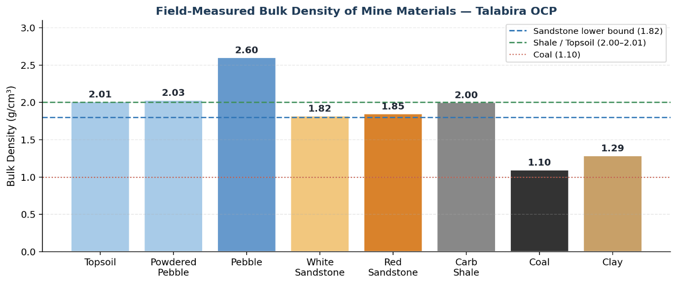

The density range across OB materials is 1.82–2.60 g/cm³, with pebble beds at the high end and sandstone at the low end. Carbonaceous shale (2.00 g/cm³) and topsoil (2.01 g/cm³) fall in the middle range. Coal, at 1.10 g/cm³, is markedly lighter than all OB materials, confirming that a single density assumption across all materials would introduce significant error in tonne-based production reporting.
Implication for Trip Factor: if the OEM TF is expressed as cum per trip at a design density of 1.8 t/cum (a typical planning assumption), but actual material is predominantly shale at 2.0 t/cum or pebble at 2.6 t/cum, the mass carried per trip is systematically higher than assumed. This independently corroborates the survey-based finding that actual TF exceeds OEM TF by ~20%.

4.2 The Three Measurement Systems at Talabira

At Talabira II & III OCP, OB volumes are monitored simultaneously by four separate measurement streams, operated by different parties. Understanding the role of each is essential before comparing their outputs.
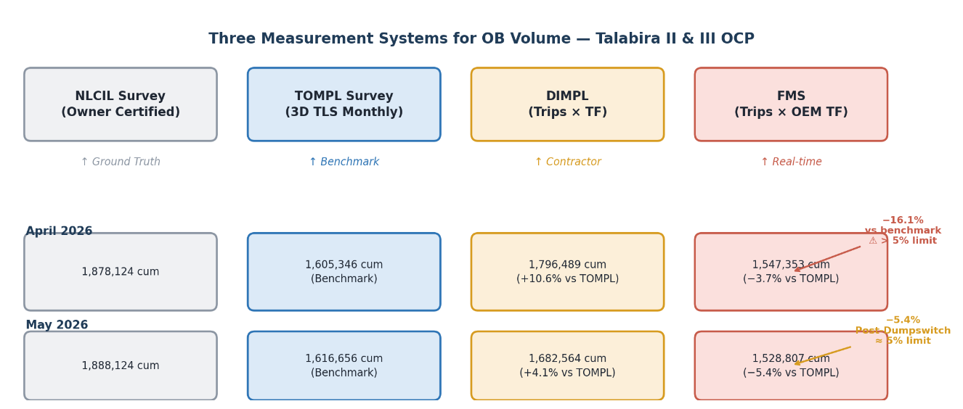

- NLCIL, as the mine owner, conducts its own independent survey each calendar month (1st to 31st).

- The TOMPL survey cycle runs from the 27th of one month to the 27th of the next.

OBSERVATION
The TOMPL 3D TLS survey is the most accurate independently verifiable volume figure available at Talabira on a monthly basis. All divergence percentages in this chapter are benchmarked against TOMPL, consistent with the site’s own data convention. An accepted tolerance of ±5% applies between survey and FMS figures.

3.3 Quantification of the FMS–Survey Divergence
The following table presents the raw monthly volume data extracted from the Talabira OB Removal FY 2026-27 register for April and May 2026.
Parameter | April 2026 | May 2026
NLCIL Survey (Owner, cum) | 18,78,124 | 18,88,124
TOMPL Survey (Benchmark, cum) | 16,05,346 | 16,16,656
DIMPL (Trips × TF, cum) | 17,96,489 | ~16,82,564
FMS (Trips × OEM TF, cum) | 15,47,353 | 15,28,807
FMS Trips (count) | 48,399 | 52,854
FMS vs TOMPL Divergence | −16.1% | −5.4%
DIMPL vs TOMPL Divergence | +10.6% | +4.1%
Acceptable Limit | ±5% | ±5%

April 2026 — Dumpswitch Failure Period
The site note records: “Dumpswitch connection work completed on 23rd April 2026, which is crucial for trip closure and quantity logging”.

The Dumpswitch connection, a proximity sensor that signals when a dumper’s body is raised at the dump point and thus confirms trip completion.

May 2026 — Post-Dumpswitch Recovery
FMS divergence: −5.4% from TOMPL benchmark (just above the 5% limit). Following the Dumpswitch repair, the FMS trip count recovered markedly (from 48,399 to 52,854 trips).
The residual 5.4% divergence after the hardware fix is attributable primarily to the static OEM TF error rather than trip undercounting, since the Dumpswitch issue was no longer active.

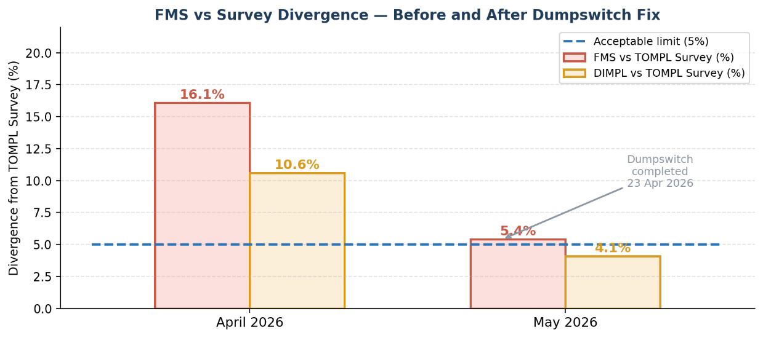

3.4 The OEM Trip Factor Error — Evidence and Quantification
The TOMPL survey does not only provide a total volume figure; it also enables a back-calculation of the effective TF actually achieved per truck class during the survey period. This is done by distributing the surveyed total volume in proportion to each truck class’s share of FMS-recorded trips and quantities, and then dividing by the trip count for that class.

Dynamic TF Formula
Survey TF (class k) = [ Survey Volume Total × (FMS Volume Share for class k) ] ÷ FMS Trips for class k
This formula apportions the verified survey volume among truck classes in proportion to how the FMS itself observed them, then recalculates what TF would have been needed to arrive at that volume with the actual trip count.

Truck Class | Model | OEM TF (cum) | Survey-Derived TF April 2026 (cum) | Difference | Error %
Small | Bharat Benz 3528CM / Volvo FMX-440 | 13 | 16 | +2.6 | +20%
Medium | Sany SKT90s / SKT105s | 25 | 31 | +5.8 | +23%
Big | Komatsu HD-785-7 | 42 | 50 | +8.4 | +20%

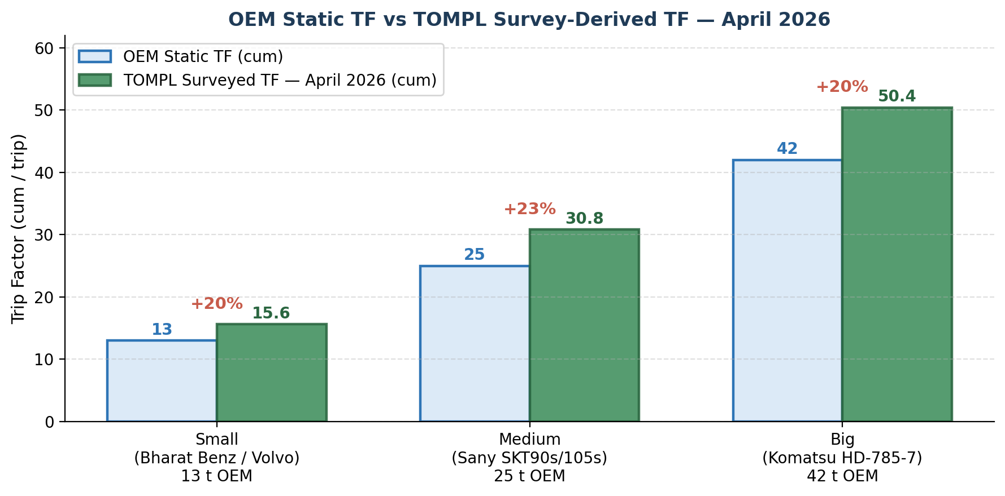
Figure 3.3 — OEM static TF vs TOMPL survey-derived TF per truck class, April 2026.
The systematic nature of the error is notable: all three truck classes show a survey-derived TF that is 20–23% higher than the OEM static value. This rules out a random loading variation effect and suggests a structural cause. Three factors likely contribute:
- Body volume vs. rated payload: OEM TF values in the FMS appear to be based on rated payload capacity in cubic metres at a reference density, rather than actual body volume. Actual in-situ OB material, being fragmented blasted rock, fills the body more completely than the design assumption.
- Material swell factor: Blasted rock occupies a larger volume than solid rock. If the OEM TF is based on solid-material density, it will underestimate the volume loaded per trip after blasting.
- Operator loading behaviour: Trucks at Talabira may be routinely loaded above rated capacity on the volumetric basis, which is common practice in production-incentivised mine environments.

3.5 The Dynamic Trip Factor Framework
Based on the evidence from previous sections, a Dynamic Trip Factor (DTF) framework is proposed. The DTF replaces the fixed OEM TF with a value that is recalibrated each survey cycle using the TOMPL 3D TLS survey as the reference.

3.5.1 Mathematical Derivation
The correction framework is built on a single deviation factor ε (epsilon), which captures the fractional error between what the FMS reports and what the survey actually measures. The sign convention is:
- ε < 0 (negative) → FMS Overstatement: FMS reports more volume than the survey. TF must be reduced.
- ε > 0 (positive) → FMS Understatement: FMS reports less volume than the survey. TF must be increased. This is the Talabira case.
General form:
TF_{ᴅʏɴᴀᴍɪᴄ} = TF_{static} × (1 + ε)

The deviation ε is computed from the monthly survey and FMS totals as:
ε = ( V_{survey} − V_{fms} ) ÷ V_{fms}
For the volume side, the same factor gives the actual volume from the FMS-reported volume:
V_{ᴀᴄᴛᴜᴀʟ} = V_{fms} × (1 + ε)

Substituting the FMS volume definition (V_{fms} = TF_{static} × N_{trips}):
V_{ᴀᴄᴛᴜᴀʟ} = TF_{static} × N_{trips} × (1 + ε)

Dividing both sides by N_{trips} yields the Dynamic TF directly:
TF_{ᴅʏɴᴀᴍɪᴄ} = TF_{static} × (1 + ε)
Applying to Talabira April 2026 (understatement case, ε > 0):
V_{survey}(TOMPL) = 16,05,346 cum
V_{fms} (FMS, OEM TF) = 13,36,625 cum
ε = (16,05,346 − 13,36,625) ÷ 13,36,625 = +0.201 (+20.1%)
TF_{ᴅʏɴᴀᴍɪᴄ} (Medium) = 25.0 × (1 + 0.201) = 25.0 × 1.201 = 31 cum
TF_{ᴅʏɴᴀᴍɪᴄ} (Big) = 42.0 × (1 + 0.201) = 42.0 × 1.201 = 50 cum

Worked Example — April 2026
Truck Class | FMS Trips | FMS Qty Share | Survey Vol Apportioned (cum) | Dynamic TF (cum/trip) | OEM TF | Uplift
Small | 1,593 | 1.55% | 24,883 | 16 | 13 | +20.10%
Medium | 39,734 | 76.2% | 12,23,713 | 31 | 26 | +20.10%
Big | 7,072 | 22.2% | 3,56,760 | 50 | 42 | +20.10%
Total | 48,399 | 100% | 16,05,346* | — | — | —

Worked Example — May 2026
Truck Class | FMS Trips | FMS Qty Share | Survey Vol Apportioned (cum) | Dynamic TF (cum/trip) | OEM TF | Uplift
Small | 828 | 0.70% | 11,382 | 14 | 13 | +5.75%
Medium | 40,960 | 68.89% | 11,13,794 | 27 | 26 | +5.75%
Big | 11,066 | 30.40% | 4,91,479 | 44 | 42 | +5.75%
Total | 52,854 | 100% | 16,16,656 | — | — | —

*Minor rounding from formula application. Benchmark: TOMPL Survey = 16,05,346 cum.

3.5.2 Computing ε: The Standard Deviation Factor from Survey vs FMS

The static OEM Trip Factor currently embedded in the Talabira FMS cannot be corrected by a single month’s data. A single anomalous month — such as April 2026, when the Dumpswitch hardware fault inflated the apparent deviation to 20.1% — would introduce a new systematic error if used uncritically for recalibration. The framework proposed here addresses this through a seven-stage weighted calibration roadmap, in which six months of parallel FMS and TOMPL survey data are collected, anomalous months are downweighed rather than excluded, and a statistically stable deviation factor ε is computed before any TF update is applied to the FMS.
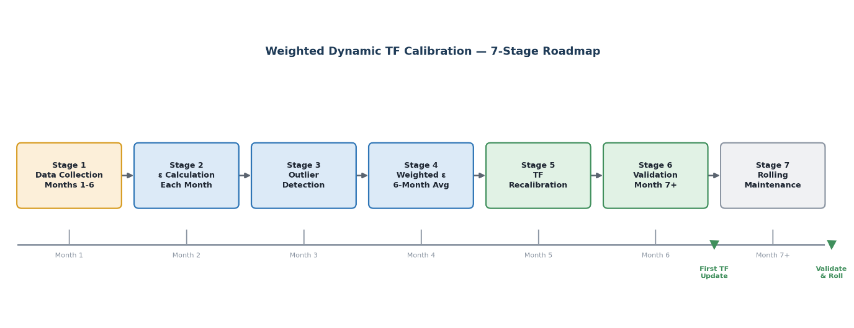

Stage 1 — Data Collection (Months 1–6)
Every month, the following data are recorded in a structured register:
- V_{survey} — TOMPL 3D TLS survey volume for the reporting cycle (27th–27th).
- V_{fms} — FMS total OB volume for the same period, broken down by truck class (Small / Medium / Big).
- N_{trips}(k) — FMS trip count per truck class.
- Hardware/software event flag — any documented issue affecting trip count or volume accuracy (Dumpswitch failure, GPS outage, FMS server downtime).

Month | V_{survey} (cum) | V_{fms} (cum) | Raw ε (%) | Hardware Issue | Weight (w)
April 2026 | 16,05,346 | 13,36,625 | 20.1% | Dumpswitch fault | 0.3
May 2026 | 16,16,656 | 15,28,807 | 5.7% | None | 1.0
June 2026 | TBD | TBD | TBD | TBD | TBD
July 2026 | TBD | TBD | TBD | TBD | TBD
August 2026 | TBD | TBD | TBD | TBD | TBD
September 2026 | TBD | TBD | TBD | TBD | TBD

Stage 2 — Monthly ε Calculation
At the end of each month, the raw deviation factor is computed as:
εᵢ = ( V_{survey} − V_{fms} ) ÷ V_{fms}
A positive ε indicates FMS is understating production (survey > FMS). A negative ε indicates overstatement (FMS > survey). The Talabira case is consistently positive, confirming systematic OEM TF underestimation.

Stage 3 — Outlier Detection and Weight Assignment
Before any month is included in the calibration average, it passes through four quality gates:
- Magnitude check: if |εᵢ| > 15%, the month is flagged for investigation before inclusion. This threshold captures genuine operational anomalies while admitting the natural 5–10% band of month-to-month variation.
- Hardware event check: any month with a documented hardware or software failure receives a reduced weight.
- Fleet composition check: if the truck fleet mix changed significantly (new truck class introduced, major fleet redeployment), the month is noted and downweighted.
- Survey cycle alignment check: if the TOMPL survey boundary misalignment exceeds four days in a high-production month, a modest weight reduction is applied.

Condition | Weight Assigned
Normal month, no issues | 1.0
Minor hardware issue (resolved within shift) | 0.7
Survey cycle mismatch > 4 days | 0.7
Significant fleet composition change | 0.5
Major hardware fault (Dumpswitch, GPS outage) | 0.3
Multiple simultaneous issues | 0.2 (or exclude)

Stage 4 — Weighted ε Calculation (6-Month Average)
After six months of data are accumulated, the weighted average deviation factor is computed:
εᴀᴅɢ = Σ ( wᵢ × εᵢ ) ÷ Σ ( wᵢ )
This calculation is performed separately for each truck class, since the structural TF error may differ between the Bharat Benz / Volvo small dumpers, the Sany SKT medium dumpers, and the Komatsu HD-785-7 large dumpers. The class-level ε values are obtained by distributing the survey volume in proportion to each class’s observed FMS volume share, as described in Section 3.6.
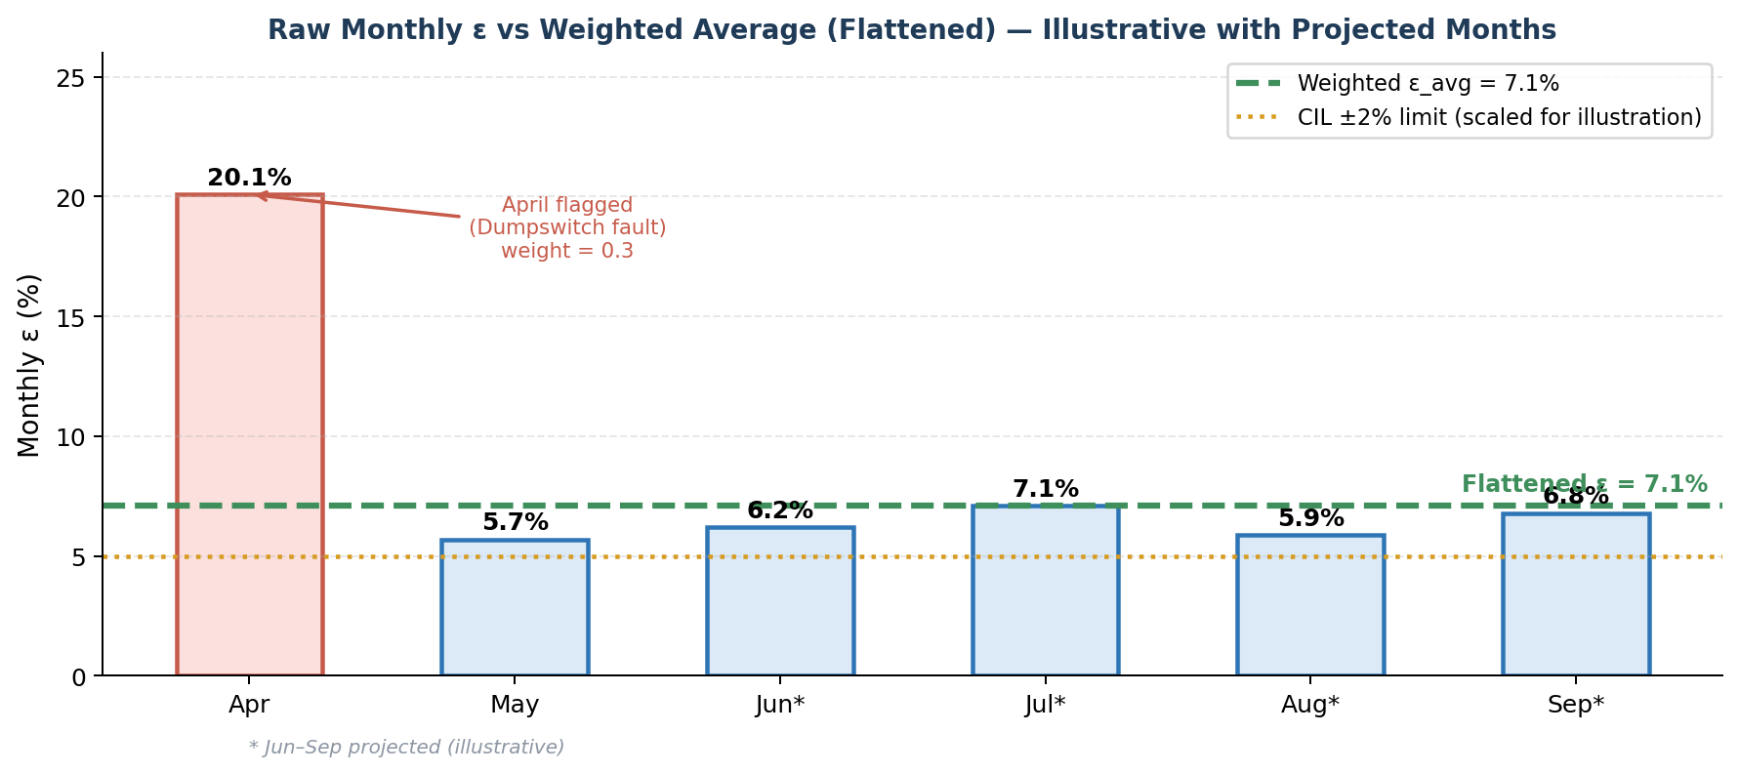

Stage 5 — TF Recalibration
The calibrated Trip Factor for each truck class is computed as:
TFᴄᴀʟɪʙʀᴀᴛᴇᴅ(k) = TFᴏᴇᴍ(k) × ( 1 + εᴀᴅɢ(k) )
The resulting values are submitted to the FMS system administrator for update in the configuration. The update requires no hardware change; it is a parameter change in the FMS server configuration.

Truck Class | OEM TF (cum) | Weighted ε_avg | Calibrated TF (cum) | Change from OEM
Small (Bharat Benz / Volvo) | 13.0 | +9.0% | 14.2 | +1.2 cum
Medium (Sany SKT90s/105s) | 25.0 | +9.0% | 27.3 | +2.3 cum
Big (Komatsu HD-785-7) | 42.0 | +9.0% | 45.8 | +3.8 cum

Note: values above are illustrative based on two confirmed months. Final calibrated TF values will be derived from the full six-month dataset.

Stage 6 — Rolling Maintenance
From month 7 onwards, the calibration operates on a rolling 3-month window (followed by 6-month). Each month, the newest data point is added and the oldest is dropped. The weighted ε_avg is recalculated. If ε_avg drifts beyond ±5% from the current TF correction, an early recalibration is triggered. Otherwise, a full TF update occurs every six months on a scheduled basis.
This rolling structure means the TF will naturally adapt to long-term operational changes — a new truck model entering the fleet, a change in bench height, or a shift in material type — without requiring manual intervention, while remaining resistant to single-month noise.

Implementation Summary

Stage | Activity | When | Who | Output
1 | Collect V_survey, V_FMS, trips, flags | Monthly | Survey + FMS team | Data register
2 | Calculate raw ε_i per month | Monthly | FMS analyst | Monthly ε table
3 | Flag anomalies, assign weights | Monthly | FMS analyst + Engineer | Weighted data table
4 | Compute weighted ε_avg over 6 months | Month 6 | Engineer | ε_avg per truck class
5 | Recalibrate TF, update FMS config | Month 6 | FMS administrator | New TF in system
6 | Validate against TOMPL survey | Month 7 onwards | Survey + FMS team | Residual ε report
7 | Roll window, monitor drift, recalibrate | Ongoing | Engineer | Updated TF every 6 months

Regulatory Compliance
The seven-stage roadmap directly addresses two provisions of the CIL Yellow Book (2011). Stage 5 (annual TF redetermination) fulfils Section 3(c), which mandates that the Dumper Factor "shall be determined once in a year." The six-monthly recalibration cycle proposed here exceeds this requirement in frequency. Stage 6 (validation against the ±2% tolerance) fulfils Section 10(ii)(b), which prescribes that for mines with quarterly OB removal exceeding 1.25 million cum, the variance between Book Stock and Measured Stock shall not exceed ±2%. Campelo and Marin (2018) independently demonstrated that unverified static truck factors introduce systematic production reporting errors across all mine KPIs, a finding that corroborates both the regulatory mandate and the analytical necessity of the roadmap presented here.
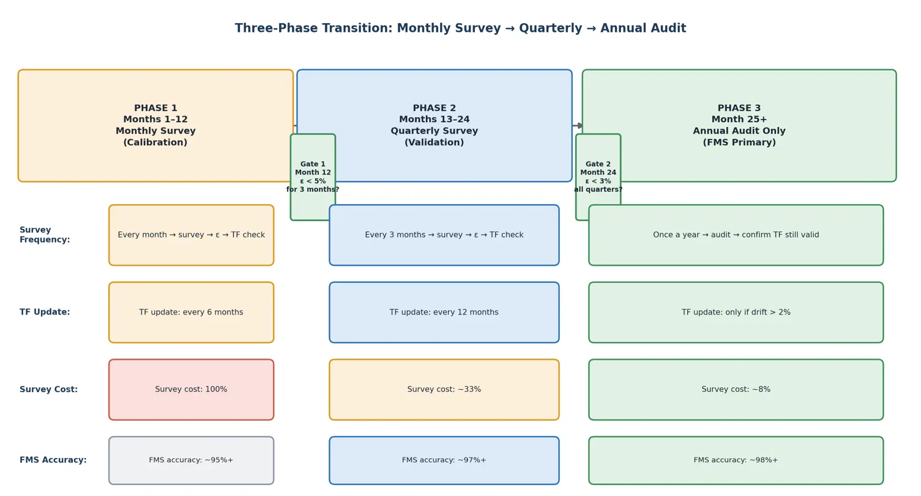

5. CAN Bus Integration for Advanced Fleet Health Monitoring
The current Fleet Management System (FMS) at Talabira II & III OCP tracks machine location, trip counts, idle hours, availability, and fuel consumption — data derived primarily from GPS position and ignition status.

It does not capture any information from the machine's internal electronics: the engine health, hydraulic condition, transmission temperature, or diagnostic fault codes that the machine itself generates every second of operation.

These signals exist — every modern HEMM produces them continuously — but they travel only within the machine's internal network and never reach the FMS. The Controller Area Network (CAN Bus) is the technology that bridges this gap.

CAN Bus (Controller Area Network) is an internationally standardised digital communication protocol used to exchange information between electronic systems within a machine.

All electronic control modules on the machine connect to this shared network and communicate using a standardised message protocol, allowing any module to read data from any other module.

Heavy earth moving machinery — including dumpers, tippers, excavators, and surface miners — adopted CAN Bus as the de facto standard for internal machine communication by the 1990s and 2000s.

Every machine at Talabira from major OEMs (Komatsu, Sany, Kobelco, Volvo, BharatBenz) has a CAN Bus network operating continuously. The question at Talabira is not whether this data exists — it does — but whether the FMS is connected to read it. Currently, it is not.

Key Point:

The Teltonika VTU units currently installed on Talabira's fleet are connected to three machine signals: GPS antenna, ignition wire, and HMR pulse wire. They have physical ports capable of connecting to the machine's CAN Bus as well — the hardware upgrade path already exists in the installed telematics unit. CAN Bus integration at Talabira is therefore an incremental enhancement of the existing system, not a replacement of it.

5.1 CAN Bus Architecture

A CAN Bus network in a mining machine consists of five fundamental layers, each performing a specific function in converting a physical measurement into a digital data point available to external systems.

Component | Examples | Function
Sensors | Temperature probe, pressure transducer, position encoder, fuel flow meter | Convert physical measurements (temperature, pressure, speed, position) into electrical signals.
Electronic Control Units (ECUs) | Engine Control Module (ECM), Transmission Control Unit (TCU), Hydraulic Control Unit (HCU) | Microprocessor modules that receive sensor signals, interpret them, and broadcast processed data onto the CAN Bus network.
CAN Bus Network | CAN High (CANH) and CAN Low (CANL) twisted pair wiring | Heart of the network
Data Packets (Frames) | Standard 11-bit or Extended 29-bit CAN frames (SAE J1939 in heavy equipment) | CAN messages are transmitted in structured data frames containing parameter identification, measured value, and error-checking information.
Telematics Gateway | Teltonika FMB640 with CAN interface, OEM telematics controllers | Connects to the CAN Bus as a read-only 'listener' node. Intercepts selected parameter broadcasts, buffers them, and transmits via cellular network to the FMS server.

5.2. Working Principle of a CAN Bus-Based Fleet Monitoring System

Stage 1 — Machine Sensors
Physical sensors distributed throughout the machine measure conditions including temperature, pressure, rotational speed, fuel flow, electrical voltage, and payload weight. These sensors are hardwired to their respective ECUs through dedicated sensor wiring looms that are separate from the CAN Bus network. The sensor layer is fixed equipment — it is already installed on all modern heavy machines and requires no modification for CAN Bus monitoring purposes.

Stage 2 — Electronic Control Units (ECUs)
Each ECU receives analogue and digital sensor signals, applies engineering unit conversions, executes control algorithms, manages fault detection and protection responses, and packages operational data into standardised J1939 Protocol Data Units (PDUs) for broadcast onto the CAN Bus. ECUs also log Diagnostic Trouble Codes (DTCs) when sensor values or system behaviour deviate from normal operating parameters, storing them in non-volatile memory accessible through the diagnostic port.

Stage 3 — CAN Bus Network
The two-wire differential CAN Bus network carries all ECU broadcasts simultaneously. Individual ECUs arbitrate access to the shared network using a priority-based non-destructive collision resolution mechanism — higher priority messages (e.g., engine protection fault codes) access the bus ahead of lower priority messages (e.g., incremental hour counter updates) without data loss.

Stage 4 — Telematics Gateway Unit
The telematics unit is connected to the CAN Bus network, typically through the standard OBD/diagnostic port (a 9-pin Deutsch connector in J1939 heavy vehicle applications) or through a direct network tap on the main bus. The unit is a read-only passive listener — it receives all network broadcasts without transmitting to the machine's control network, ensuring that its installation cannot affect machine control functions.

Stage 5 — Cellular or Satellite Communication
The telematics unit transmits aggregated data packages to the central server using cellular data (4G LTE in areas of coverage. During periods of network outage — in deep pits, tunnels, or remote workings — data is stored locally on the unit's internal memory and transmitted automatically upon restoration of network connectivity without data loss.

Stage 6 — Central FMS Server
The server receives incoming data, validates message integrity, associates data records with the correct asset and operator session, and stores them in a scalable time-series database. Processing services apply alert rules — comparing incoming parameter values against configured thresholds — and generate maintenance work orders or operator notifications when conditions are met.

Stage 7 — Management Dashboard
The dashboard provides real-time and historical visibility into fleet health and performance. Maintenance supervisors access DTC alerts and parameter trend plots to investigate developing faults. Fleet managers review utilisation, production, and fuel efficiency reports. Mine management accesses consolidated KPI dashboards showing fleet availability, MTBF trends, fuel cost per BCM, and operator performance metrics.

5.3 Parameters Available Through CAN Bus
Parameter | Description | Operational Significance
Engine RPM | Rotational speed of engine crankshaft in revolutions per minute | Indicates engine loading, helps identify over-speeding or underpowering conditions that accelerate wear
Fuel Rate | Instantaneous fuel consumption in litres per hour | Enables real-time burn monitoring, identifies inefficient operation, sudden spikes indicate mechanical stress
Fuel Consumption | Cumulative fuel used over a shift or trip | Used for payload-per-litre efficiency KPIs and budget tracking; baseline for anomaly detection
Engine Load % | Percentage of rated engine output currently being utilised | Sustained high load without adequate cooling causes accelerated cylinder wear and thermal fatigue
Coolant Temperature | Engine coolant circuit temperature in degrees Celsius | Overheating is a primary cause of engine seizure; alerts can prevent catastrophic failure
Oil Pressure | Engine lubricating oil circuit pressure in kPa | Low pressure indicates oil starvation, potential bearing damage, or pump failure
Hydraulic Pressure | Pressure within the hydraulic actuation circuits | Abnormal readings indicate pump degradation, valve leakage, or cylinder seal failure
Transmission Temperature | Automatic transmission fluid temperature | Elevated temperature indicates torque converter slippage or cooling circuit blockage
Battery Voltage | Electrical system voltage at the alternator and battery terminals | Identifies charging system faults, prevents unexpected electrical shutdowns in operation
Fault Codes (DTCs) | Standardised Diagnostic Trouble Codes broadcast by ECUs on fault detection | Enables precise fault identification without manual inspection; records intermittent faults
Engine Hours | Cumulative running hours recorded by engine ECU | More accurate than FMS-derived operating hours; used for service scheduling and asset lifecycle tracking
Idle Time | Time engine runs with no load or productive motion | Excessive idling wastes fuel and contributes to component wear; key for operator behaviour analysis
Speed | Ground speed in km/h from ECU (more accurate than GPS-derived speed) | Identifies speeding events, ramp speed violations, overspeed faults near personnel areas

Note: The fundamental limitation of the current configuration is not a deficiency in the FMS platform itself but rather in the data available to it. Modern FMS platforms are designed to consume and analyse CAN Bus data. The hardware and software capability exists; the missing element is the physical connection between the telematics unit and the machine's CAN Bus network. This is, in implementation terms, a hardware integration and configuration project rather than a fundamental system replacement.

5.4 Correlation of CAN Bus Capabilities with Findings at Talabira II & III OCP

Finding from This Report | Current Limitation | CAN Bus Resolution
K-007 progressive breakdown (697→744 hrs/month) | Cause cannot be identified using FUMS | Fuel Rate, Engine Load, RPM and DTCs distinguish operator behaviour from mechanical faults.
61 Q4 machines with unknown failure modes | Breakdown hours recorded but failure modes unknown | DTCs provide machine-level failure mode information for RCA.
EX-164: 1,043 idle hours vs possible data artefact | GPS speed cannot distinguish digging from idle | Hydraulic pressure and boom activity improve work-state detection.
Static TF limitation | Fixed payload assumption | Payload data enables validation of actual loading and supports Dynamic TF.
High MTTR | Diagnosis begins after machine reaches workshop | Fault codes available before inspection reduce troubleshooting time.
V-series Tipper fleet renewal decision — no cumulative repair cost data | No continuous health monitoring | Engine parameters and DTC trends support condition monitoring and renewal decisions.

5.5 Phased Implementation Roadmap for CAN Bus Integration
The five phases build on each other sequentially — each phase's output is the input the next phase needs (baselines → thresholds → ROI evidence → fleet-wide expansion → continuous improvement).
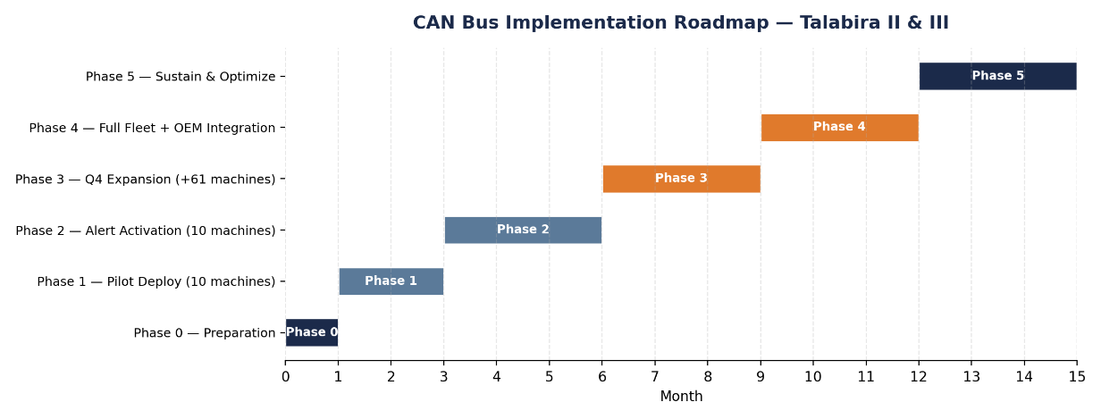

Phase | Duration | Machines | Key Output
0 — Prep | Month 1 | 0 | Harnesses ordered, OEM PGN maps obtained
1 — Pilot Observe | Month 2–3 | 10 | Baselines established, K-007 DTC evidence
2 — Alert Activate | Month 4–6 | 10 | MTTR improvement measured, ROI evidence
3 — Q4 Expansion | Month 7–9 | +61 | Failure Code Analysis begins
4 — Full Fleet | Month 10–12 | Remaining | Operator scoring, payload data, Match Factor dashboard
5 — Sustain | Month 13+ | All | Continuous improvement cycle

Phase 0 — Preparation (Month 1)
This phase primarily involves technical assessment and planning activities. Except for procurement of pilot CAN harnesses, no significant capital expenditure or machine modification is required.

Actions
- Verify that the installed Teltonika firmware supports CAN Bus communication and update it where necessary.
- Obtain OEM-specific J1939 parameter documentation from the respective equipment manufacturers or authorised service representatives.
- Identify and verify the location of the CAN diagnostic interface on representative machines from each OEM.
- Select a representative pilot fleet comprising benchmark machines, high-breakdown machines, and machines exhibiting operational anomalies.

Pilot Machine Selection
Machine | Rationale
K-002 | Best-performing K-series dumper — benchmark
K-007 | Worst-performing — confirmed breakdown trajectory
BB-590 | Tipper benchmark, MTBF 708 hrs
V-246 | Fully non-operational — confirm DTC stream
EX-164 | Idle-hour anomaly — confirm/clear with hydraulic pressure data
S-059 | Lowest fleet MTBF (13.3 hrs)
L-010 | FEL idle anomaly
S-221 / S-254 / S-371 | Operational S-series dumpers from efficiency cluster

Phase 1 — Pilot Deployment, Observation Only (Month 2–3)

Installation of CAN harnesses on the 10 pilot machines during scheduled maintenance windows

Initial Parameters Set
- All machines: Engine RPM, Coolant Temp, Oil Pressure, Fuel Rate, Engine Hours, Active DTCs (DM1), Battery Voltage.
- Dumpers add: Transmission Oil Temp, Gear Position, Payload Weight (Komatsu only).
- Excavators add: Hydraulic Oil Temp, Hydraulic Pump Pressure.

Baseline Development

Thresholds should not be activated during the pilot period because machine health parameters vary across equipment classes and individual machines. An initial observation period is therefore required to establish Talabira-specific baseline operating conditions before condition-monitoring thresholds are configured.

End-of-Phase Deliverable
- Baseline Machine Health Database
- Parameter Trend Analysis
- Equipment-specific Operating Baselines
- Pilot Performance Evaluation Report

Phase 2 — Alert Activation & Maintenance Integration (Month 4–6)

Transform machine health information collected during the pilot phase into actionable maintenance intelligence through condition-based monitoring and structured maintenance response.

Parameter | Recommended Alert Strategy
Coolant Temperature | Baseline Mean + 2σ, subject to OEM operating limits
Engine Oil Pressure | Significant deviation below established baseline
Transmission Temp | Baseline deviation and OEM operating limits
Diagnostic Trouble Codes | Repeated occurrence of identical fault codes within a defined monitoring period
Fuel Rate | Sustained deviation above established operating baseline

Workflow Integration

When a monitored parameter exceeds its configured threshold:
- An automated notification is generated through the Fleet Management System.

- The maintenance supervisor and shift engineer review the alert.

- A decision is made to either: continue monitoring or schedule preventive maintenance

- The maintenance action and final outcome are recorded within the maintenance management system for future performance evaluation.
Phase 3 — Q4 Fleet Expansion (Month 7–9, +61 Machines)

Objective

Expand CAN Bus monitoring to the highest-risk production equipment and integrate machine health information into the mine's reliability and maintenance management processes.

Key Activities

- Extend CAN Bus connectivity to equipment groups exhibiting the highest breakdown frequency and maintenance burden, with priority given to machines classified in the Q4 reliability quadrant.

- Apply equipment-specific baseline parameters established during the pilot phase to machines of the same OEM and equipment class, reducing the need for prolonged baseline observation while allowing further refinement using operational data.

- Begin systematic analysis of Diagnostic Trouble Codes (DTCs) and J1939 SPN data to identify recurring failure modes across equipment groups.

- Integrate DTC analysis with the Failure Code Framework proposed in Chapter 3 to support component-level root cause analysis.

- Review preventive maintenance schedules and inspection checklists using the accumulated machine health information.

Phase 4 — Full Fleet & OEM Integration (Month 10–12)

Objective

Complete fleet-wide deployment of CAN Bus monitoring and integrate machine health information

Key Activities

Extend CAN Bus connectivity across the remaining technically compatible production fleet.

Where OEM telematics platforms are available, evaluate opportunities to integrate existing machine data with the Fleet Management System to improve parameter availability and reporting.

Develop operator performance indicators using machine health parameters including engine RPM, idle duration, fuel consumption, gear selection, and braking behaviour.

Integrate onboard payload information, where available, with the Dynamic Truck Factor framework developed in Chapter 5 to improve production measurement accuracy.

Phase 5 – Continuous Improvement and Predictive Maintenance (Month 13 Onwards)

Objective

Transition from condition monitoring to a continuous improvement and predictive maintenance framework.

6. Towards Digital Mine: Future Technology Integration
The preceding chapters established a diagnostic and corrective foundation for fleet management at Talabira II & III OCP: reliability and utilisation analysis identified where operating hours were being lost, the Dynamic Truck Factor framework proposed a practical methodology for reducing systematic bias in production reporting through periodic TLS survey reconciliation, and the proposed CAN Bus architecture addressed the current system's inability to observe machine health.
Taken together, these chapters point to four recurring limitations in the existing Fleet Management System: imprecise production measurement, reactive rather than predictive maintenance, restricted visibility into machine condition, and operational decisions made without an integrated view of the mine.
This chapter does not revisit these findings. Instead, it presents a set of technologies that build directly on them, extending the existing FMS/FUMS platform in a practical and incremental manner.
The intent is not to propose a wholesale replacement of current systems, but to describe a realistic pathway by which Talabira II & III can progressively evolve toward a Digital Mine — one in which production, maintenance, and machine health data are measured continuously and viewed through a single operational picture.

6.1 Payload Management System (PMS)
Chapter 4 demonstrated that the static Truck Factor historically used at Talabira II & III introduces a measurable and systematic error in reported production volume, and proposed a Dynamic Truck Factor framework, calibrated through periodic 3D TLS survey reconciliation, as a correction. The Dynamic TF framework substantially improves the accuracy of production estimation at the fleet and period level. However, it remains, by design, a periodic calibration method: it corrects the average relationship between FMS-reported and survey-measured volume over a given interval, but it does not measure the payload carried on any individual trip. A truck that is significantly underloaded or overloaded on a given cycle is not distinguishable from one operating at its calibrated average.
A Payload Management System addresses this at the point of loading. Suspension pressure sensors or hydraulic load cells fitted to the truck's suspension or chassis measure the change in load as material is placed in the dumper body. This raw signal is processed by an onboard controller or the machine's existing Engine Control Unit (ECU), which converts pressure or strain readings into an estimated payload figure for that specific trip. Where the vehicle is already equipped with CAN Bus connectivity — as proposed for the pilot fleet in Chapter 5 — this payload value is transmitted as an additional CAN Bus parameter alongside the health parameters already discussed, and reported to the central Fleet Management System together with the trip's GPS and cycle-time data. The result is a continuous, trip-by-trip payload record integrated into the same reporting pipeline the FMS already uses for location and production data, rather than a separate parallel system.

A Payload Management System is not proposed as a replacement for the Dynamic Trip Factor framework developed in Chapter 5. The two serve complementary and distinct measurement functions. Dynamic TF, calibrated through periodic 3D TLS survey reconciliation, provides an aggregate correction across an entire survey cycle and remains necessary for equipment not fitted with PMS. A Payload Management System provides continuous, trip-level payload measurement independent of survey timing, but only for the specific machines on which it is installed. A Payload Management System represents the logical next evolution of the Dynamic Trip Factor framework — progressing from periodic, survey-calibrated estimation toward continuous, machine-measured confirmation, with the two methods operating in parallel until PMS coverage is extended across the full dumper fleet.

6.2 AI-Based Predictive Maintenance

Current State
Maintenance practice at Talabira II & III, as characterised in earlier chapters, is largely reactive: a machine is attended to once it has already failed or once a fault has become apparent to the operator. Chapter 5 proposed CAN Bus integration specifically to close this gap, by giving the Fleet Management System visibility into machine-internal parameters — coolant and transmission temperature, hydraulic and oil pressure, vibration, fuel rate, and Diagnostic Trouble Codes — that are presently invisible to it. Once this data is available continuously, it can be used for more than threshold-based alerting.
Practical Application
Artificial intelligence and machine learning techniques can be applied to this CAN Bus data stream to identify gradual, pre-failure trends that would not trigger a simple fixed-threshold alarm but are nonetheless indicative of developing mechanical distress. Rather than waiting for a parameter to breach a hard limit, a trend-based model can recognise the trajectory of a parameter over time —
for instance, a transmission temperature that is rising steadily across several shifts, considered together with a pattern of recurring, related Diagnostic Trouble Codes. Consider machine K-007, identified in Chapter 3 as one of the fleet's chronic reliability concerns. Under the current arrangement, K-007's transmission would be expected to fail without significant advance warning, resulting in an unplanned breakdown and an extended repair duration. Under a predictive maintenance arrangement, a gradual rise in transmission temperature together with repeated related DTCs could instead be interpreted by the model as a leading indicator, allowing maintenance planning to flag "transmission failure likely within approximately 100 operating hours" and to schedule a controlled repair — with parts and crew arranged in advance — before the failure occurs in the field.
This capability is a natural extension of the CAN Bus implementation proposed in Chapter 5: the sensing and data infrastructure required for predictive maintenance is the same infrastructure already recommended for basic condition monitoring, with the analytical layer added once sufficient operating history has accumulated.

6.3 Digital Twin of the Mine

Concept
A Digital Twin, in the context of Talabira II & III, is best understood not as a futuristic abstraction but as a real-time digital representation of ongoing mine operations, built by consolidating data that already exists across separate systems onto a single operational dashboard. Rather than introducing new sensing hardware, a Digital Twin integrates information already produced by the Fleet Management System, the Fuel Management System, the proposed Payload Management System, CAN Bus health data, GPS positioning, and periodic survey data, presenting it as one coherent operational picture instead of several disconnected reports.
Practical Example
Consider again machine K-007. Under current arrangements, understanding its full status requires checking several separate systems: the FMS for its location and trip history, the FUMS for its fuel consumption, maintenance records for its repair history, and — once implemented — CAN Bus data for its current health parameters. Under a Digital Twin arrangement, a mine manager could instead view all of this information for K-007 on a single screen: its current location, its most recent payload readings, its fuel consumption trend, its live machine-health parameters, and its maintenance history, together with a system-generated maintenance recommendation if a fault is developing. This consolidated view removes the need to cross-reference multiple systems manually, and allows a developing issue to be assessed in its full operational context — for example, understanding immediately whether a nearby spare truck is available to cover K-007 if it needs to be withdrawn for repair.
Why This Improves Decision-Making
The value of a Digital Twin lies less in any single new measurement and more in the elimination of fragmentation between existing data sources. Dispatch, maintenance, and production-planning decisions at present depend on information that resides in separate systems, checked separately, often by different personnel. A unified operational view reduces the time and effort required to assemble a complete picture of a situation and makes it easier to see the relationship between a machine-health event and its production or dispatch consequences as they occur, rather than reconstructing that relationship afterward from separate records.
Long-Term Positioning
A Digital Twin should be regarded as a long-term integration goal rather than a near-term deliverable: it depends on the Payload Management System and CAN Bus architecture discussed above and in Chapter 5 already being operational and generating reliable data. Positioned appropriately, however, it represents the technological foundation on which more advanced capabilities — including automated dispatch optimisation

7. Conclusion
This study systematically evaluated the fleet performance at Talabira II & III OCP, with each chapter building upon the findings of the preceding one.

- Chapter 2 established the existing Fleet Management System architecture, its capabilities, and its key limitations, particularly in production measurement and equipment health monitoring.

- Chapter 3 assessed fleet reliability through Availability, MTBF, MTTR, and the Reliability Matrix, uncovering critical maintenance issues and highlighting priority improvement areas.

- Chapter 4 demonstrated the shortcomings of Static Truck Factors and proposed a Dynamic Truck Factor framework, using TLS survey reconciliation to significantly enhance production measurement accuracy.

- Chapter 5 illustrated how CAN Bus integration can overcome current Fleet Management System limitations by enabling real-time equipment health monitoring and facilitating a shift toward condition-based maintenance, supported by a phased implementation roadmap.

- Chapter 6 explored forward-looking technologies, including Payload Management Systems and other digital solutions, that hold strong potential to further improve production measurement, maintenance practices, and overall fleet efficiency.

Overall, this study demonstrates that substantial gains in fleet performance, productivity, and reliability are achievable through better utilisation of operational data, rigorous engineering analysis, and the phased adoption of digital technologies. The findings provide a clear, practical roadmap for enhancing decision-making and operational excellence at Talabira II & III OCP.

